**FSDM / CPCM – 2023S**

**Database Design & SQL**

**Student ID:** 901142  
**Student Name:** Roshan Shrestha  
**Practical Exercise 13_14_15_16**

**Fig 1**

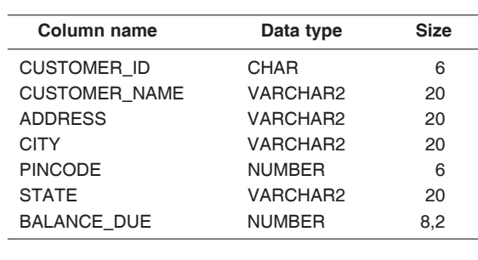

Figure : Table structure

**Fig 2** page1image27955264

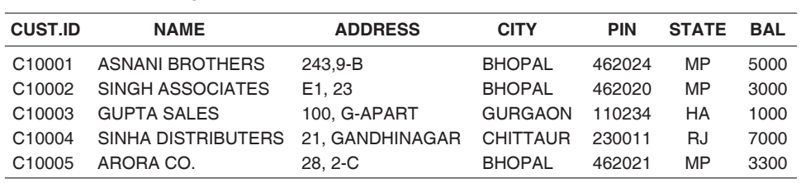

Figure : Values inside table

**Practical Activity #1**

First, we need to execute the query to construct the **"CUSTOMERS_142"** table in the Oracle database using the column names and datatypes it contains, as shown in figure 1. The query is below:

**CREATE TABLE CUSTOMERS_142 (**

**CUSTOMER_ID CHAR (6),**

**CUSTOMER_NAME VARCHAR2(20),**

**ADDRESS VARCHAR2(20),**

**CITY VARCHAR2(20),**

**PINCODE NUMBER (6),**

**STATE VARCHAR2(20),**

**BALANCE_DUE NUMBER (8,2))**

Explanations of each line of table creation SQL query:

* To construct a new table with the name **"CUSTOMERS_142"** the query starts with **"CREATE TABLE CUSTOMERS_142"**.
* The following columns will be in the table:
  + The **"CUSTOMER_ID"** column, which has a **"CHAR (6)"** data type. It can hold as many as six characters.
  + **"VARCHAR2(20)"** data type for the "**CUSTOMER_NAME"** column. It can hold strings with a configurable length of up to 20 characters.
  + **"VARCHAR2(20)"** data type for the **"ADDRESS"** field. It can hold strings with a configurable length of up to 20 characters.
  + **"VARCHAR2(20)"** data type for the **"CITY"** column. It can hold strings with a configurable length of up to 20 characters.
  + **"PINCODE"** column with **"NUMBER (6)"** as the data type. It can store numbers with up to six digits.
  + A column named **"STATE"** with the data type **"VARCHAR2(20)"**. It can hold strings with a configurable length of up to 20 characters.
  + **"BALANCE_DUE"** column containing a data type of **"NUMBER (8,2)"**. It can store numerical values up to eight digits with two decimal places.

**For the execution of the query and visualizing the output I have used live oracle from <https://livesql.oracle.com/>. The executed query and it’s result output have been attached with screenshots below:

Figure 3: Query to create new table.

Figure 4: Created table structure.

**Practical Activity #2**On the second step to insert the data into the **“CUSTOMERS_142”** table as shown in figure 2, we need to execute the **“INSERT”** query with appropriate values as below:

1. **INSERT INTO CUSTOMERS_142 (CUSTOMER_ID, CUSTOMER_NAME, ADDRESS, CITY, PINCODE, STATE, BALANCE_DUE) VALUES ('C10001', 'ASNANI BROTHERS', '243,9-B', 'BHOPAL', 462024, 'MP', 5000);**
2. **INSERT INTO CUSTOMERS_142 (CUSTOMER_ID, CUSTOMER_NAME, ADDRESS, CITY, PINCODE, STATE, BALANCE_DUE) VALUES ('C10002', 'SINGH ASSOCIATES', 'E1,23', 'BHOPAL', 462020, 'MP', 3000);**
3. **INSERT INTO CUSTOMERS_142 (CUSTOMER_ID, CUSTOMER_NAME, ADDRESS, CITY, PINCODE, STATE, BALANCE_DUE) VALUES ('C10003', 'GUPTA SALES', '100, G-APART', 'GURGAON', 110234, 'HA', 1000);**
4. **INSERT INTO CUSTOMERS_142 (CUSTOMER_ID, CUSTOMER_NAME, ADDRESS, CITY, PINCODE, STATE, BALANCE_DUE) VALUES ('C10004', 'SINHA DISTRIBUTERS', '21, GANDHINAGAR', 'CHITTAUR', 230011, 'RJ', 7000);**
5. **INSERT INTO CUSTOMERS_142 (CUSTOMER_ID, CUSTOMER_NAME, ADDRESS, CITY, PINCODE, STATE, BALANCE_DUE) VALUES ('C10005', 'ARORA CO.', '28, 2-C', 'BHOPAL', 462021, 'MP', 3300);**

A single row of data is added to the table with each **INSERT** operation. The values offered in the **VALUES** clause match the columns in the table structure's defined order. The following figure illustrates the insert queries that were executed:

Figure 5: Query to insert values to table.

The data inserted into the table can be visualized in the picture below:

Figure 6: Inserted Values in the table

**Practical Activity #3**To update the table with the given values we need to execute the following query along with the new values. The query is below:

**UPDATE CUSTOMERS_142 SET CITY = 'INDOR' WHERE CUSTOMER_NAME = 'ASNANI BROTHERS';**

**UPDATE CUSTOMERS_142 SET ADDRESS = 'E2,24-C', BALANCE_DUE = 10000 WHERE CUSTOMER_NAME = 'SINGH ASSOCIATES'**

The first **UPDATE** query replaces **"BHOPAL"** with **"INDORE"** as the city of the client with the name **"ASNANI BROTHERS"**. In the second **UPDATE** query, the customer with the name **"SINGH ASSOCIATES"** has their address changed to **"E2, 24-C"** and their **BALANCE_DUE** value increased to **10,000**. The executed query and it’s result can be visualized from the screenshot below:

Figure 7: Query to update columns in the table.

Figure 8: Updated columns with new values

**Practical Activity #4**

For deleting the records from the table, we can use **“DELETE”** query.

The required query to delete the records for **“SHINHA DISTRIBUTERS”** we can use the following query:

**DELETE FROM CUSTOMERS_142 WHERE CUSTOMER_NAME = 'SINHA DISTRIBUTERS';**

Similarly, to delete the customers with balance below 4000, we can use the following query:

**DELETE FROM CUSTOMERS_142 WHERE BALANCE_DUE < 4000;**

The executed query and the output are attached in below screenshots:

Figure 9: Delete columns based on given condition.

Lastly, to delete the entire table we can use **“DROP”** query as shown below:

Figure 10: Updated table after deletion of columns

**DROP TABLE CUSTOMERS_142;**

The executed query can be visualized in screenshot below:

Figure 11: Drop the table

As we have erased the entire table along with its columns containing data, when we try to execute the query to retrieve the table, it gives us error explain that the requested table doesn’t exist anymore as shown in below screenshot:

Figure 12: Retrieve the deleted table